Sponsorship Guideline
The 10th Asian Photochemistry Conference (APC2018) will be held on 16th-20th December, 2018 at Taipei, Taiwan. The conference attracts researchers and students from around the world to discuss latest findings in the field of photochemistry. The Conference expects to attract 350 attendees from countries such as Japan, India, Korea and Australia. This year’s theme include: photophysics and photochemistry, photobiology and photosynthesis, spectroscopy and dynamics, plasmonics and nanophotonics, solar energy materials and photocatalysis, photoluminescent and photochromic materials, bioimaging, biosensing, and phototherapy.
The benefits for you
- Opportunity to expose your company to attendees around the world.
- Personal interaction with potential customers/collaborators.
- Logos and/or advertisement to appear in conference booklet.
- Recognition on the conference website.
- Invitation to attend conference banquet at Silks Palace (2 persons per sponsorship)
Sponsorship package:
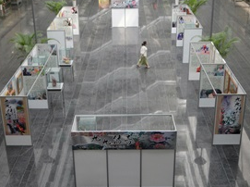
- Exhibition Booth ($100,000NTD)
- Display period: 17th – 20th December, 2018.
- Location: Level 2 & 3 of Howard Civil International House, Taipei, Taiwan. (See below for detailed floor plan)
- 1m x 3m exhibition booth.
- Standard booth setup contains: 1 table(60x180cm), 2 chairs, 2 spotlights, 1 electricity socket (110V). For additional requirement please specify on registration form.
- Oral Presentation ($20,000NTD)
- 20minutes oral presentation during lunch breaks (limited time slot available).
- Poster ($20,000NTD)
- Poster presentation on 17th~18th December, 2018. (Poster dimension: 200cm(H)x95cm(W))
APC2018 Sponsor Application Form
Name
☐ Exhibition Booth ☐ Booth + Oral Presentation ☐ Poster
Contact Person: |  | Phone |  | Email
Name on Receipt |  |  | Tax ID number
Mailing address
Note
